**S3cmd on SUSE Linux Setup Guide**

**Install**

* Boot up Virtual Machine
  + If Azure VM, go to Azure portal and find the SUSE VM and “Start” it
* SSH (log into) into SUSE VM
  + Need IP and Username and Password (can be found and reset in Azure Portal page for respective VM)
    - Username and Password are case sensitive
  + Use Putty SSH tool for Windows, Terminal tool for Linux or OSX
  + Verify logged in correctly when you see the command prompt
    - 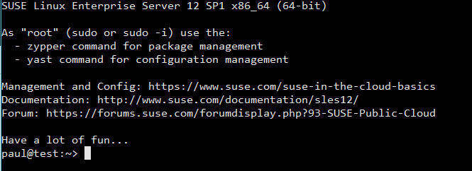
* Create and navigate to temporary install directory
  + mkdir /var/tmp/s3
  + cd /var/tmp/s3
* Install
  + Download S3cmd compressed file to /var/tmp folder
    - wget <http://ufpr.dl.sourceforge.net/project/s3tools/s3cmd/1.6.1/s3cmd-1.6.1.tar.gz>
  + Extract S3cmd compressed file
    - tar -xf s3cmd-1.6.1.tar.gz
  + Navigate to S3cmd Install folder
    - cd s3cmd-1.6.1
  + Run installation file
    - sudo python setup.py install
    - Enter root (sudo) password when prompted
  + After install is finished, remove installation files
    - cd /var/tmp
    - sudo rm s3 -rf

**Configure**

* s3cmd - -configure
* Type in Access Key of AWS account when prompted
  + Created when setting up AWS account, need admin to provide
* Type in Secret Access Key of AWS account when prompted
  + Created when setting up AWS account, need admin to provide
* Press [Enter] key when prompted for default region
* Create encryption password
  + *Text not hidden*
* Press [Enter] key when prompted for path to GPG program
* Press [Enter] key when prompted to use HTTPS protocol
* Press [Enter] key when prompted for HTTP proxy path
* Type in “Y” when prompted to test setup
* Confirm that test worked
  + If not, troubleshoot by making sure AWS account access set up properly and the Access keys are correct and type in “N” and then type in “n”
  + If yes, type in “y” to finish configuration

**Use**

* To list all objects or buckets
  + s3cmd ls
* To list all objects inside of buckets
  + s3cmd la
* To download an object from bucket to local VM Hard Drive
  + Navigate over to directory you want to save file (through cd)
    - i.e cd /home
  + s3cmd get s3://bucket_name//object_name
    - Or just s3cmd get s3://bucket_name/ for whole bucket

**Command List for S3cmd**

* <https://linux.die.net/man/1/s3cmd>

**Easy copy and paste notation of above commands (copy here and just right click into Putty / Terminal to paste)**

mkdir /var/tmp/s3

cd /var/tmp/s3

wget <http://ufpr.dl.sourceforge.net/project/s3tools/s3cmd/1.6.1/s3cmd-1.6.1.tar.gz>

tar -xf s3cmd-1.6.1.tar.gz

cd s3cmd-1.6.1

sudo python setup.py install

cd /var/tmp

sudo rm s3 -rf

s3cmd --configure

s3cmd ls

s3cmd la

s3cmd get s3://bucket_name//object_name

s3cmd get s3://bucket_name/